# **Memory**

1. A machine has 48 bit virtual addresses and 32 bit physical addresses. Pages are 8 KB. How many entries are needed for the page table?

With 8-KB pages and a 48-bit virtual address space, the number  
of virtual pages is 2^48/2^13, which is 2^35 (about 34 billion).

1. For each of the following decimal virtual addresses, compute the virtual page number and offset for a 4-KB page and for an 8 KB page: 20000, 32768, 60000.

For a 4-KB page size the (page, offset) pairs are (4, 3616), (8, 0), and (14, 2656). For an 8-KB page size they are (2, 3616), (4, 0), and (7, 2656).  
[ Note: You should specify your starting index, like either from 0 or from 1 etc.]

2.1 Page size = 4KB

|  |  |  |
| --- | --- | --- |
| Virtual address | Page number | Offset |
| 20000 | 5000 | 20000mod4096=3616 |
| 32768 | 8192 | 0 |
| 60000 | 15000 | 2656 |

2.2 Page size = 8KB

|  |  |  |
| --- | --- | --- |
| Virtual address | Page number | Offset |
| 20000 | 2500 | 20000mod 2^13=3616 |
| 32768 | 4096 | 32768mods^13=0 |
| 60000 | 7500 | 60.000mod2^13= 2656 |

1. The figure below shows a virtual address space from 0 to 64K and 32K of physical memory. There are 16 pages and 8 frames and transfers between memory and disk are in pages. Give the physical address corresponding to the following virtual addresses, explain how did you get the answer?:

a) 20 b) 4100 c) 8300

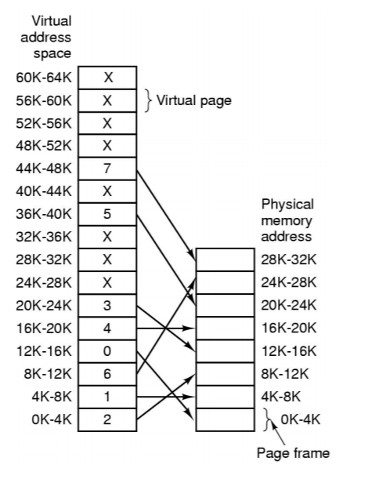

1. Suppose a virtual address space of 2^28 words and the page size is 2^12 words. If the virtual address is 18000 in Decimal , what would be the page number in Decimal?

1. A computer has 2GB RAM of which the operating system occupies 1GB.   
   The processes are all 450 MB and have the same characteristics. How many percent is CPU utilization when these programs are idle waiting for I/O 20% of the time?

96%

1. How many percent of the CPU time is wasted, when a computer system has enough room to hold two program and these programs are idle waiting for I/O 10% of the time?

99%.

1. Consider a swapping system in which memory consists of the following hole sizes in memory order: 10 KB, 4 KB, 20 KB, 18KB, 7 KB, 9KB, 12 KB, and 15 KB. Which hole is take for successive segment requests of 12 KB, 10KB, 9KB for worst fit?

20kb, 18kb, 15kb.

7. Consider a swapping system in which the memory consists of the following hole sizes: 10K, 4K, 20K, 15K, 9K. Assume worst fit algorithm is used. Which holes are taken for successive segment requests of 8K,

10k, 20k, 15k.

8. If there are 64 pages and the page size is 2048 words, what is the length of logical address?

17 bits

9. A system with 32 bit virtual address. If the page size is 4 KB and each table entry occupies 4 bytes, what is the size of the page table?

4MB

11. Assume the Memory Manager receives a request for a block of 200. When the worst-fit algorithm is used, ____ is the beginning address of the block granted by the Memory Manager.

Beginning Address - Memory Block Size

4075 - 105

5225 - 5

6785 - 600

7560 - 20

7600 - 205

10250 - 4050

Ans = 7600.

12. Suppose a virtual address space of 2^28 words and the page size is 2^12 words. If the virtual address is 18000 in Decimal , what would be the page number in Decimal?

Page number = 180000 / 4096 + Offset: 1616 🡪 Page Number: 4 (16k-20k)

15. Consider a swapping system in which memory consists of the following hole sizes in memory order: 10 KB, 4 KB, 20 KB, 18KB, 7 KB, 9KB, 12 KB, and 15 KB. Which hole is take for successive segment requests of 12 KB, 10KB, 9KB for worst fit?

20Kb, 18 kb, 15kb.

16. A memory free in 3 frames. How many page fault occur after running as the following page 7, 0 , 1, 2 , 0, 3, 0 , 4, 2 , 3 , 0 , 3 , 2 , 1, 2, 0, 1, 0 , 7 using FIFO

|  |  |  |  |  |  |  |  |  |  |  |  |  |  |  |  |  |  |  |  |
| --- | --- | --- | --- | --- | --- | --- | --- | --- | --- | --- | --- | --- | --- | --- | --- | --- | --- | --- | --- |
|  | **7** | **0** | **1** | **2** | **0** | **3** | **0** | **4** | **2** | **3** | **0** | **3** | **2** | **1** | **2** | **0** | **1** | **0** | **7** |
| F1 |  |  |  |  |  |  |  |  |  |  |  |  |  |  |  |  |  |  |  |
| F2 |  |  |  |  |  |  |  |  |  |  |  |  |  |  |  |  |  |  |  |
| F3 |  |  |  |  |  |  |  |  |  |  |  |  |  |  |  |  |  |  |  |
| PF |  |  |  |  |  |  |  |  |  |  |  |  |  |  |  |  |  |  |  |

Answer: 12 times.

17. A memory free in 4 frames. How many page faults do occur after running as the following page 2 3 2 0 1 5 2 4 5 3 2 5 2 using LRU

Answer: 7

|  |  |  |  |  |  |  |  |  |  |  |  |  |  |
| --- | --- | --- | --- | --- | --- | --- | --- | --- | --- | --- | --- | --- | --- |
|  | **2** | **3** | **2** | **0** | **1** | **5** | **2** | **4** | **5** | **3** | **2** | **5** | **2** |
| F1 |  |  |  |  |  |  |  |  |  |  |  |  |  |
| F2 |  |  |  |  |  |  |  |  |  |  |  |  |  |
| F3 |  |  |  |  |  |  |  |  |  |  |  |  |  |
| F4 |  |  |  |  |  |  |  |  |  |  |  |  |  |
| PF |  |  |  |  |  |  |  |  |  |  |  |  |  |

18. A computer provides the user with virtual address space of 2^32  
 (2 to the power 32) bytes. Pages of size 4096 (4K or 2^12) bytes  
 are used for implementing virtual memory where the total physical  
 memory is equal to 2^18 bytes. If the hexadecimal virtual  
 address is 23456111, the page number in hexadecimal would be:

19. A computer has 1024MB of memory, with OS taking 128 MB and each user program also taking up 128MB with an 80% average I/O wait? How percentage of CPU utilization does?

79%

20. A computer has 1GB of memory, with OS taking 635 MB and each user program also taking up 25 MB in average, with an 70% average I/O wait. The CPU utilization is 99.53%

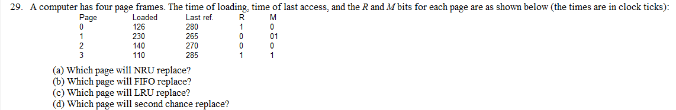

Nru=2;  
 (b) Which page will FIFO replace?

Page 3   
 (c) Which page will LRU replace?

Page 0 because it hasn’t been used.

(d) Which page will second chance replace?

Page 0.

22 A computer has four page frames. The time of loading, time of last  
 access, and the R and M bits for each page are as shown below   
 (the times are in clock ticks):  
  
 Page Loaded Last Ref. R M  
 0 230 285 1 0  
 1 120 265 0 0  
 2 140 270 0 1  
 3 110 280 1 1  
  
 (a) Which page will NRU replace?

Nru=2;  
 (b) Which page will FIFO replace?

Page 3   
 (c) Which page will LRU replace?

Page 0 because it hasn’t been used.

(d) Which page will second chance replace?

Page 0.